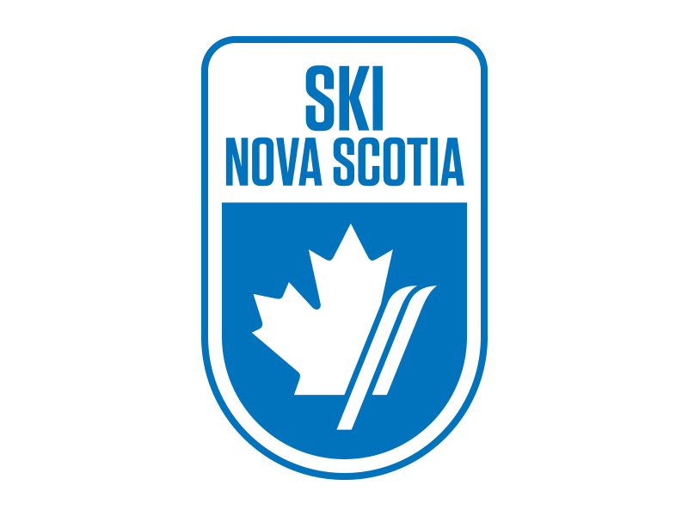
RACE NOTICE
Atlantic Cup Series Jerry Giorno Memorial Cup, Ben Eoin Ski Team
Ski Cross and Slalom U8 and up
LOCATION / COURSE – Ski Ben Eoin, SX Track – Loonback, Slalom - Eagle
SANCTION – Alpine Ski Nova Scotia / Alpine Canada Alpin
DATES – Saturday and Sunday, February 8th and 9th, 2020
ELIGIBILITY - U8 and up
RACING RULES – ACA rules will govern. All protests to be submitted in writing within 15 minutes of DSQ. Protest fee is $50.
ENTRY DEADLINE – Saturday, February 1st, 2020
ENTRY FEE –
SX - $65 only
SL - $60 only
Total: $125.00 includes 2-day lift pass for each racer and two coach lift tickets per team.

Additional lift tickets are available at a cost of $25 per day.

Cheques are payable to Ben Eoin Ski Team and are to be submitted at the Coach’s meeting on Friday, February 7th, 2020. Or via e-transfer to redrosevp@hotmail.com with BEST2018 as the password. *One cheque per team please.

ENTRIES – Send all entries via email to Nancy Nippard, Chief of Administration, at beneoinskiteam@gmail.com. Please list athlete’s full name, National #, gender, DOB, category and Club.
DEPOSIT – There will be a $100 bib/course pull deposit per team. Cheques to be submitted at the Coach’s meeting and are refundable after return of all bibs and after course tear down.
VOLUNTEERS – Ben Eoin Ski Team is asking each club to provide 4 Gate Keepers plus experienced Course Crew with their racer entries. Gate keepers will meet in the main chalet at 9:30am on Saturday and 8:00am Sunday.
RACE COMMITTEE – Co-Chiefs of Race – Bettina Callary and Kevin Elworthy. Technical Director (SX and SL) – Scott Carr. Chief of Course – Jason Richards. Chief of Gates – Kelly Greencorn. Chief of Timing – Bob Pelley. Race Secretary – Nancy Nippard
COACH’S MEETING – Friday, February 7th, 2019 at 4:30pm at Ski Ben Eoin boardroom upper level main chalet. It is mandatory for each team to have a coach, representative present at this meeting.
LIFT TICKETS – $25.00
OFFICIAL BOARD - DSQs will be posted at the bottom of the stairs in the main chalet.
EQUIPMENT – Helmets are mandatory. All athletes must wear alpine Ski racing helmets. Race suits permitted for Slalom ONLY.
SCHEDULE –
Saturday – Ski Cross. Course Inspection 9:30, Training Runs 9:30am, Qualifying 11:00 am, Heat lists will be generated upon completion of qualifying. Awards to follow on Saturday.
Sunday – Slalom: Two run combined race for U14 and up and U12 and under is two one run races. Bibs will be available in the boardroom of the chalet on Sunday morning at 7am.
Training runs 7:15 am. Course inspection 8:30am, First run 9:15am, Re-set upon completion (details at coaches meeting).
Watch the Ben Eoin Ski Team public Facebook page for updates on what special food services will be available at the hill for the race weekend!
AWARDS – Ski Cross medals will be presented on the deck of the Ski Ben Eoin main chalet after Saturday’s races. Slalom medals will be presented on the deck of Ski Ben Eoin main chalet after Sunday’s races.
ACCOMODATIONS -
The Lakes at Ben Eoin – 902-828-2277
Holiday Inn Express Sydney - 902-562-7500
Travellodge Sydney - 902-539-6750
Cambridge Suites – 902-562-6500

